COMPLY Website Documentation
Screenshots, page-by-page description, UX notes, and content inventory
https://comply-website.vercel.app
Prepared: June 05, 2026
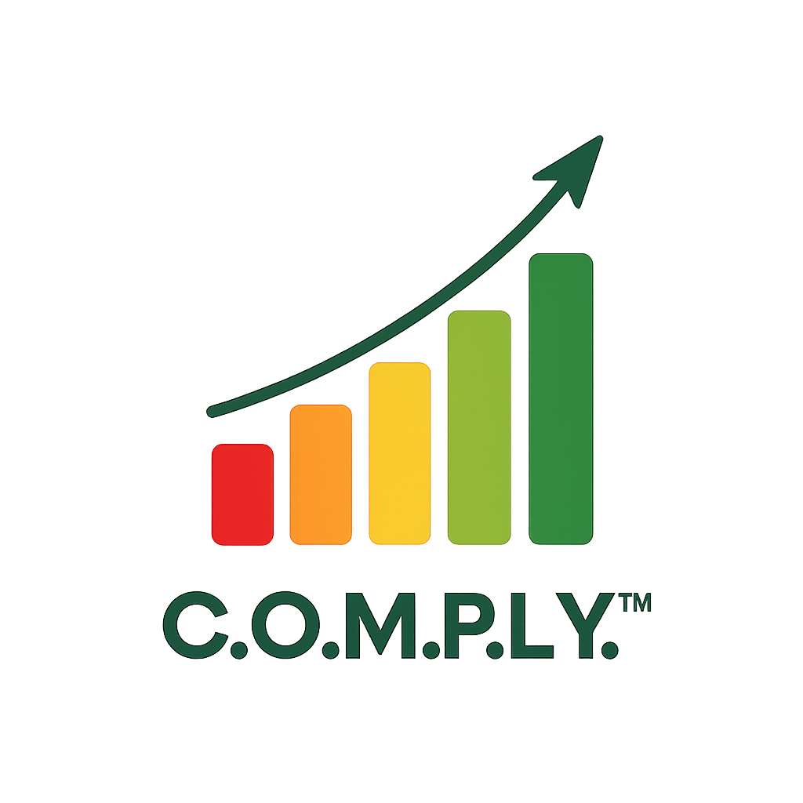
Scope
This document covers the full public COMPLY website currently deployed at comply-website.vercel.app. It includes screenshots captured from the production site and detailed descriptions of the purpose, structure, visual design, content, and conversion role of each page.

Executive Summary
The COMPLY website presents a premium enterprise security compliance and governance message. The site is designed for CIOs, CISOs, compliance leaders, GRC teams, internal auditors, risk managers, and executive leadership teams. Its core message is that COMPLY helps organizations achieve and demonstrate security compliance through evidence-driven governance, traceability, continuous oversight, reusable artifacts, and audit-defensible outcomes.
• The Home page establishes the brand narrative and introduces the compliance operating model.
• Solutions and Services translate the model into buyer-facing solution areas and consulting offerings.
• How It Works explains the lifecycle from assessment through continuous improvement.
• Platform documents the operating model in more technical detail, including controls, evidence, risk, requirements, tooling, and reporting.
• Resources, About, and Contact support conversion, credibility, and lead capture.

Website Navigation and Page Inventory
Page | URL | Primary role | Screenshot captured
Home | https://comply-website.vercel.app/ | Primary brand and conversion entry point for COMPLY. | home-viewport.png
Solutions | https://comply-website.vercel.app/solutions | Solution taxonomy page for executive and practitioner buyers. | solutions-viewport.png
Services | https://comply-website.vercel.app/services | Service catalog for consulting, readiness, review, and program improvement work. | services-viewport.png
How It Works | https://comply-website.vercel.app/how-it-works | Process explanation page showing the COMPLY lifecycle. | how-it-works-viewport.png
Platform | https://comply-website.vercel.app/platform | Platform and operating-model page grounded in the ComplyDB architecture. | platform-viewport.png
Resources | https://comply-website.vercel.app/resources | Resource hub for gated and educational content. | resources-viewport.png
About | https://comply-website.vercel.app/about | Company positioning, mission, approach, and differentiator page. | about-viewport.png
Contact | https://comply-website.vercel.app/contact | Consultation request and lead capture page. | contact-viewport.png

Site-Wide Design and Experience Notes
• Visual style: dark-and-light enterprise SaaS aesthetic with restrained cards, executive typography, strong whitespace, and compliance-specific diagrams.
• Navigation: persistent top navigation includes Home, Solutions, Services, How It Works, Platform, Resources, About, and Contact, with a persistent Schedule a Consultation CTA.
• Brand imagery: transparent COMPLY logo artwork appears in non-Home page heroes and in the Home hero visual area.
• Content pattern: pages combine concise executive headings with operational descriptions, framework references, traceability language, and outcome-oriented cards.
• Conversion pattern: the site consistently moves users toward scheduling a consultation or downloading the COMPLY Model White Paper.
• Technical presentation: production pages were captured from Vercel, and the screenshot pass reported no browser console or page errors.

1. Home Page
https://comply-website.vercel.app/

Screenshot
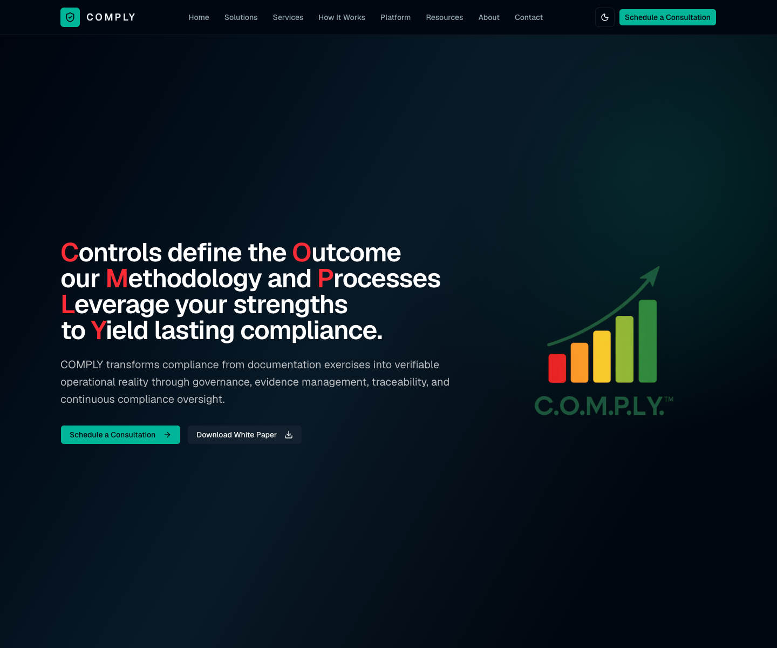
Home page first-viewport screenshot captured from production.

Page purpose
Primary brand and conversion entry point for COMPLY.

Detailed description
The Home page introduces COMPLY as an evidence-driven compliance operating model. It opens with a high-impact executive headline, a right-side brand image, and clear calls to schedule a consultation or download the white paper. The page then moves through customer challenges, solution pillars, model foundations, framework coverage, traceability, key outcomes, and governance visibility.

Major content areas
• Hero: Presents the central COMPLY message, visually emphasizing the acronym letters in the headline and pairing the copy with the COMPLY logo artwork.
• Customer challenges: Identifies the practical failures that weaken compliance programs, including non-operational controls, weak evidence, duplicated framework work, audit fatigue, poor traceability, and disconnected artifacts.
• COMPLY solution: Organizes the offer around achieving, demonstrating, and sustaining compliance.
• Model foundations: Explains Unified Controls, UCC, COMPLY Artifacts, traceability, evidence reuse, governance, risk-driven controls, gap detection, and defensibility.
• Compliance coverage: Shows the framework breadth across ISO, SOC 2, NIST, PCI DSS, CIS, GDPR, DORA, and NIS2.
• Evidence traceability, outcomes, and governance visibility: Reinforces how COMPLY connects requirements, controls, evidence, audit conclusions, oversight, and executive decision-making.

User experience and visual design
The page functions as the master narrative. It uses dark executive styling for the hero, card-based scanning for challenges and outcomes, and visual diagrams to make compliance traceability tangible.

Conversion and business role
Primary conversion is “Schedule a Consultation”; secondary conversion is “Download White Paper.” The rest of the page reduces ambiguity by showing why the model is needed and what outcomes it supports.

Captured page headings
Controls define the Outcome our Methodology and Processes Leverage your strengths
to Yield lasting compliance. — COMPLY transforms compliance from documentation exercises into verifiable operational reality through governance, evidence management, traceability, and continuous compliance oversight.
Compliance programs fail when proof and operation drift apart. — COMPLY addresses the gaps that prevent organizations from turning documented intent into audit-defensible operational reality.
One operating model for achieving, demonstrating, and sustaining compliance. — Build security and compliance programs aligned with leading standards and frameworks.
The compliance model behind defensible evidence. — These principles connect Unified Controls, UCC (Universal Control Criteria), evidence artifacts, traceability, risk, and governance into one auditable operating model.
One Compliance Program. Multiple Frameworks. — A unified control structure creates reusable evidence across security, privacy, resilience, and governance obligations.
Requirement -> Control -> Evidence -> Audit Conclusion — Every conclusion is tied to governance ownership, control operation, and validated evidence.
Defensible outcomes for executives and auditors. — Every audit conclusion is supported by traceable evidence that links requirements, controls, criteria, artifacts, owners, and review activity. This gives auditors and leadership a clear basis for understanding why a conclusion is reasonable and how it was supported.
Executive oversight without losing operational detail. — COMPLY connects accountability, reviews, control status, and evidence quality into a governance model leaders can act on.

2. Solutions Page
https://comply-website.vercel.app/solutions

Screenshot
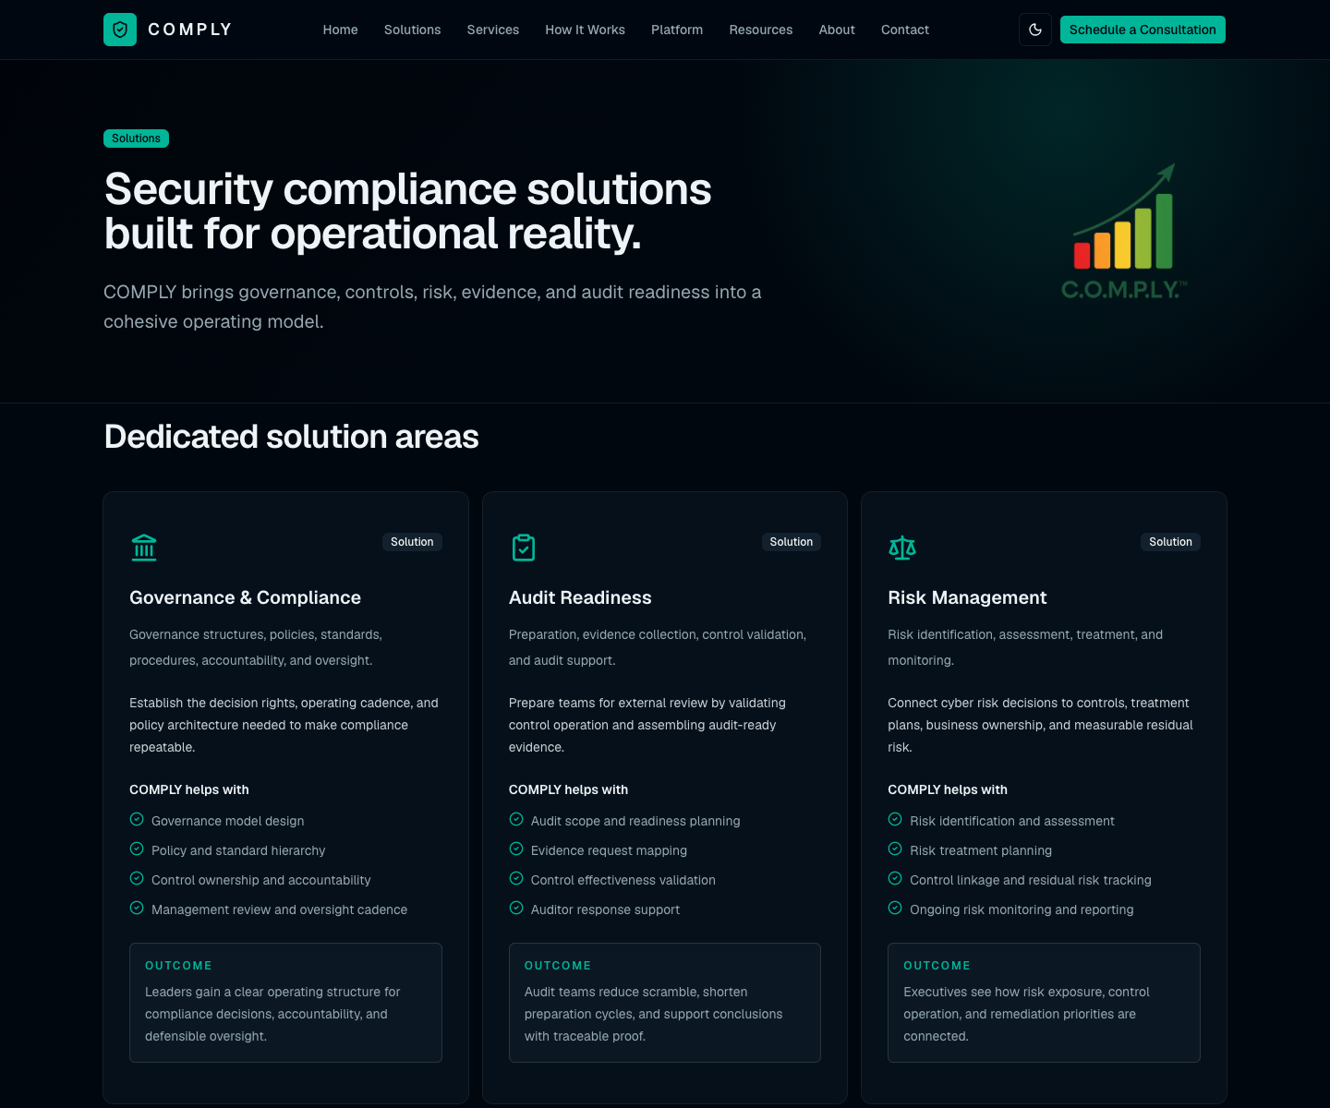
Solutions page first-viewport screenshot captured from production.

Page purpose
Solution taxonomy page for executive and practitioner buyers.

Detailed description
The Solutions page organizes COMPLY around six dedicated solution areas: Governance & Compliance, Audit Readiness, Risk Management, Compliance Management, Continuous Compliance, and Evidence Management. Each solution card includes a plain-language description, a focus statement, included activities, and a target outcome.

Major content areas
• Dedicated solution areas: Defines each solution with scope, practical activities, and outcome-oriented value.
• Evidence chain: Shows that each solution reinforces the same requirement-to-control-to-evidence-to-report traceability model.

User experience and visual design
The compact hero keeps the solution grid close to the top of the page. Cards are balanced, operational, and written for both executives and compliance owners.

Conversion and business role
The page helps a buyer map their pain point to a COMPLY solution area before moving to consultation or service discussions.

Captured page headings
Security compliance solutions built for operational reality. — COMPLY brings governance, controls, risk, evidence, and audit readiness into a cohesive operating model.
Dedicated solution areas — Governance structures, policies, standards, procedures, accountability, and oversight.
Every solution reinforces the evidence chain. — Requirement

3. Services Page
https://comply-website.vercel.app/services

Screenshot
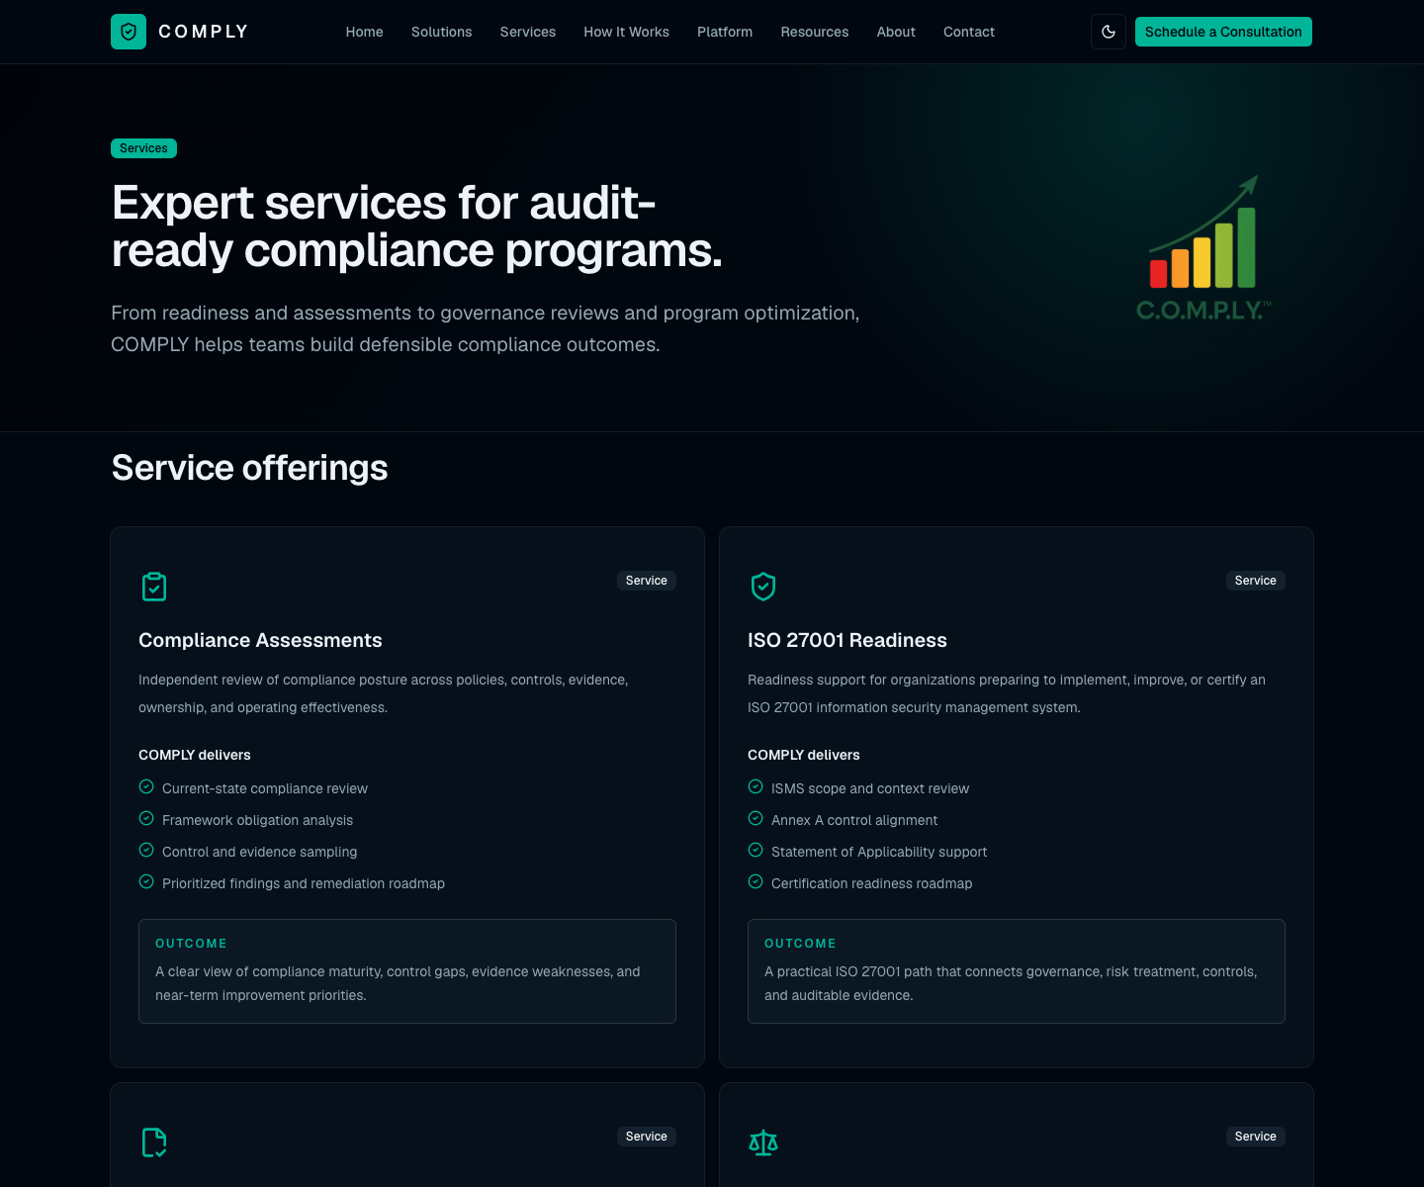
Services page first-viewport screenshot captured from production.

Page purpose
Service catalog for consulting, readiness, review, and program improvement work.

Detailed description
The Services page presents practical engagement offerings such as compliance assessments, ISO 27001 readiness, SOC 2 readiness, risk assessments, gap assessments, internal audit services, governance reviews, control effectiveness reviews, compliance program development, and optimization.

Major content areas
• Service offerings: Each service card explains what COMPLY delivers and the expected outcome for the client.
• Audit readiness journey: Shows a clear movement from scope through mapping, validation, packaging, and audit support.

User experience and visual design
The service cards are wider than solution cards to support more operational detail. The page is designed for users who already know they need help and want to understand the type of engagement.

Conversion and business role
The page prepares visitors to request a consultation with enough context to choose the right advisory or readiness path.

Captured page headings
Expert services for audit-ready compliance programs. — From readiness and assessments to governance reviews and program optimization, COMPLY helps teams build defensible compliance outcomes.
Service offerings — Independent review of compliance posture across policies, controls, evidence, ownership, and operating effectiveness.
A clear journey from scope to audit support. — Scope

4. How It Works Page
https://comply-website.vercel.app/how-it-works

Screenshot
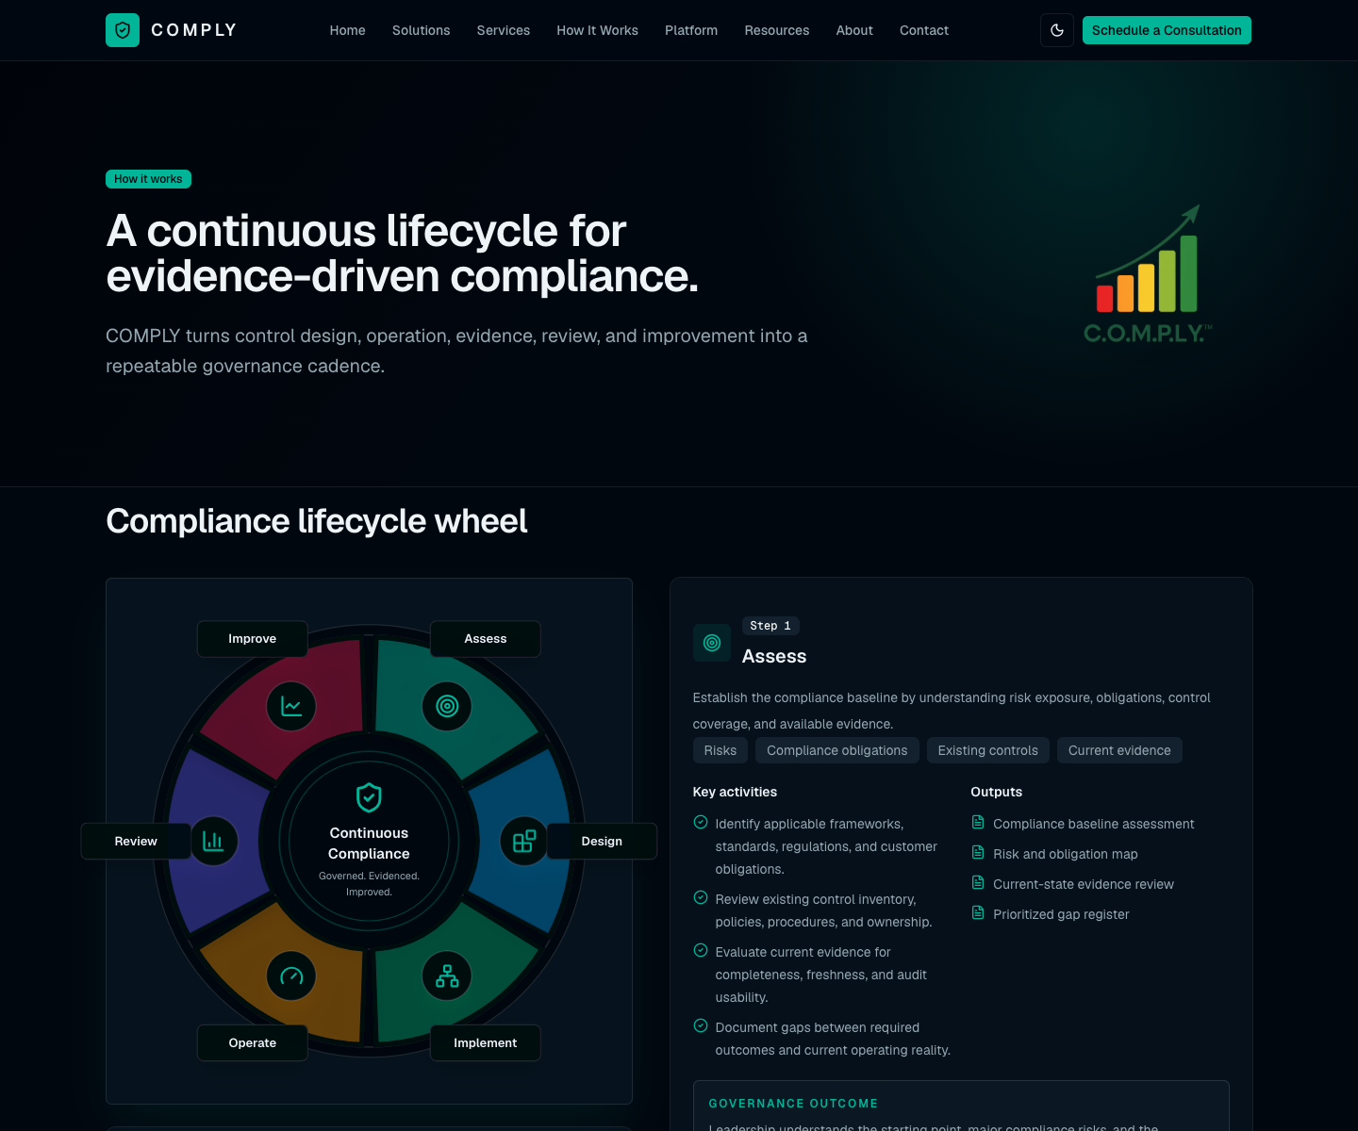
How It Works page first-viewport screenshot captured from production.

Page purpose
Process explanation page showing the COMPLY lifecycle.

Detailed description
The How It Works page documents the lifecycle through six stages: Assess, Design, Implement, Operate, Review, and Improve. The visual compliance lifecycle wheel remains prominent while the detailed step cards explain activities, deliverables, and outcomes.

Major content areas
• Compliance lifecycle wheel: A professional segmented wheel communicates continuous compliance as a repeatable operating cycle.
• Step cards: Each lifecycle phase includes risks, obligations, controls, evidence, governance, monitoring, internal audit, KPI analysis, corrective actions, and continuous improvement.

User experience and visual design
The sticky lifecycle wheel supports orientation as the user scrolls through the process. The layout reinforces that compliance is continuous and governed, not a one-time audit sprint.

Conversion and business role
This page helps buyers understand what working with COMPLY looks like in practice and how methodology turns into controlled execution.

Captured page headings
A continuous lifecycle for evidence-driven compliance. — COMPLY turns control design, operation, evidence, review, and improvement into a repeatable governance cadence.
Compliance lifecycle wheel — Continuous Compliance

5. Platform Page
https://comply-website.vercel.app/platform

Screenshot
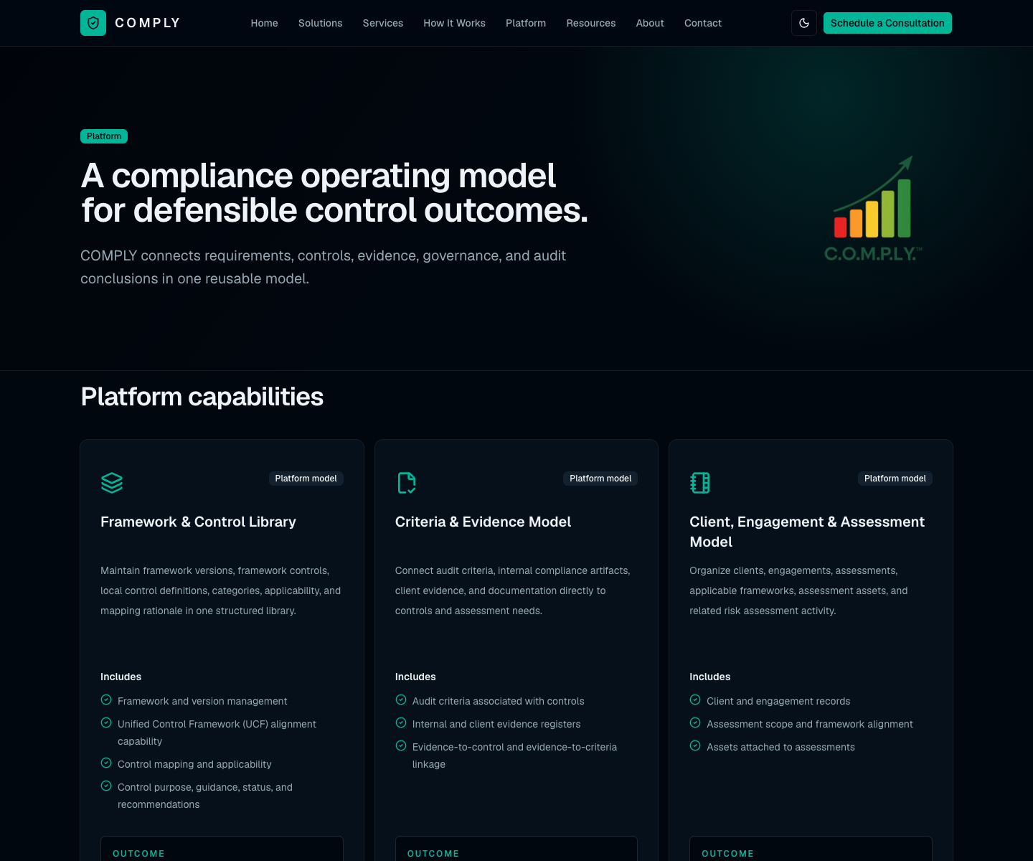
Platform page first-viewport screenshot captured from production.

Page purpose
Platform and operating-model page grounded in the ComplyDB architecture.

Detailed description
The Platform page positions COMPLY as a compliance operating model and operational database. It covers the framework and control library, criteria and evidence model, client/engagement/assessment model, asset/vulnerability/threat/risk model, legal/regulatory/contractual requirements, and security stack/tooling model.

Major content areas
• Platform capabilities: Describes each architectural capability with includes and outcomes.
• Architecture metrics: Summarizes the underlying model with tables, relationships, layouts, scripts, and value lists.
• Traceability and governance: Shows how requirements connect to framework controls, local controls, criteria, evidence, reporting, ownership, review, and oversight.
• Risk-to-control workflow and reporting: Documents how assets, vulnerabilities, threats, evaluations, treatments, controls, registers, reports, and workflow outputs connect.

User experience and visual design
This is the most technical executive page. It uses architecture-backed cards and diagrams to demonstrate substance behind the marketing language.

Conversion and business role
The page is useful for CISOs, GRC leaders, internal auditors, and technical stakeholders who need proof that COMPLY has a structured operating model.

Captured page headings
A compliance operating model for defensible control outcomes. — COMPLY connects requirements, controls, evidence, governance, and audit conclusions in one reusable model.
Platform capabilities — Maintain framework versions, framework controls, local control definitions, categories, applicability, and mapping rationale in one structured library.
An operational database for compliance, audit, risk, and control management. — The COMPLY platform model brings frameworks, controls, audit criteria, evidence, client assessments, assets, vulnerabilities, threats, risk treatment, obligations, and security tooling into one connected system of record.
Requirement -> Framework Control -> Local Control -> Evidence -> Report — Requirement
Ownership, accountability, review cycles, and oversight. — Framework and control library
Risk-to-control-to-evidence workflow. — Asset
Audit-ready registers, reports, and workflow outputs. — COMPLY supports practical operating workflows: selection cards, linked records, review states, evidence packaging, reporting, and exports.

6. Resources Page
https://comply-website.vercel.app/resources

Screenshot
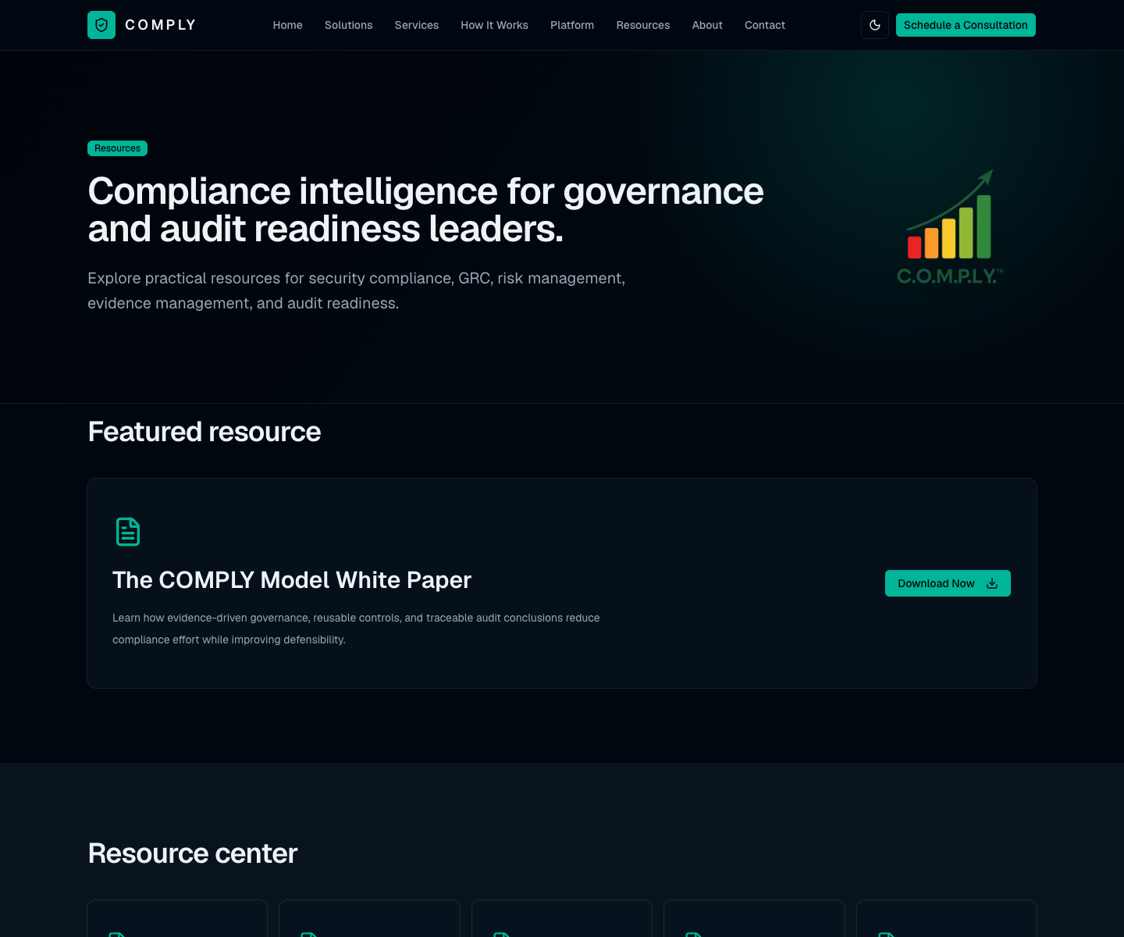
Resources page first-viewport screenshot captured from production.

Page purpose
Resource hub for gated and educational content.

Detailed description
The Resources page is centered on the COMPLY Model White Paper and groups additional resources into white papers, compliance guides, risk management guides, governance resources, and audit readiness resources.

Major content areas
• Featured resource: Promotes The COMPLY Model White Paper with a download call to action.
• Resource center: Presents content categories that support the broader compliance and governance education journey.

User experience and visual design
The page is intentionally simple and conversion-oriented. It gives visitors a clear path to the main thought-leadership asset while leaving room for future content expansion.

Conversion and business role
The primary conversion is “Download Now,” routed through the contact path.

Captured page headings
Compliance intelligence for governance and audit readiness leaders. — Explore practical resources for security compliance, GRC, risk management, evidence management, and audit readiness.
Featured resource — Learn how evidence-driven governance, reusable controls, and traceable audit conclusions reduce compliance effort while improving defensibility.
Resource center

7. About Page
https://comply-website.vercel.app/about

Screenshot
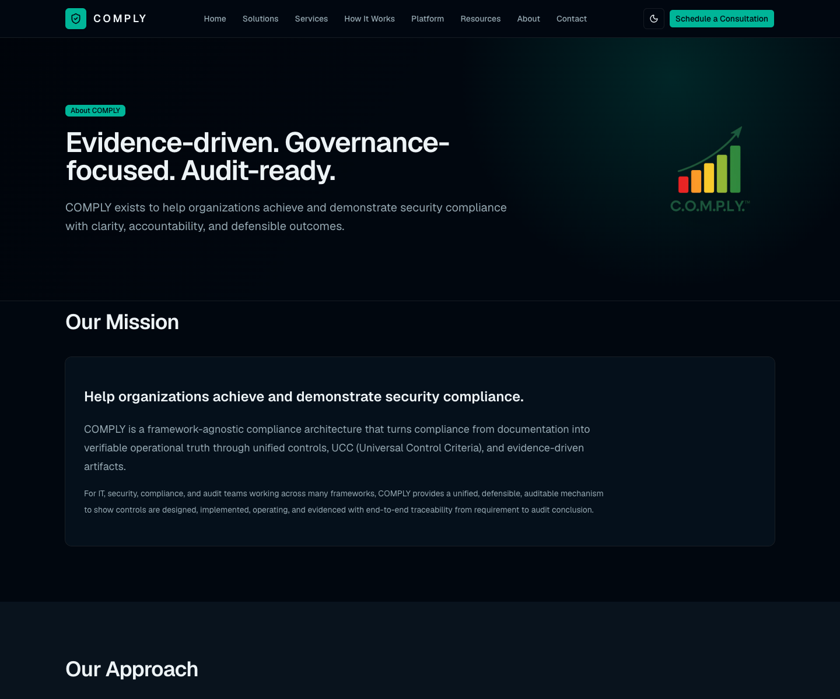
About page first-viewport screenshot captured from production.

Page purpose
Company positioning, mission, approach, and differentiator page.

Detailed description
The About page explains COMPLY’s mission to help organizations achieve and demonstrate security compliance. It expands the approach into evidence-driven, governance-focused, and audit-ready principles, then explains why COMPLY is differentiated through Unified Controls, UCC, COMPLY Artifacts, evidence reuse, and continuous compliance governance.

Major content areas
• Our Mission: Defines COMPLY as a framework-agnostic compliance architecture that turns documentation into verifiable operational truth.
• Our Approach: Explains the evidence-driven, governance-focused, and audit-ready operating philosophy.
• Why COMPLY: Details the differentiators that make the model defensible and reusable across frameworks.

User experience and visual design
The page uses a restrained executive design with explanatory cards to make the company philosophy and methodology easy to scan.

Conversion and business role
The page builds credibility and trust for visitors evaluating whether COMPLY’s model is more than a generic compliance message.

Captured page headings
Evidence-driven. Governance-focused. Audit-ready. — COMPLY exists to help organizations achieve and demonstrate security compliance with clarity, accountability, and defensible outcomes.
Our Mission — Help organizations achieve and demonstrate security compliance.
Our Approach — COMPLY treats evidence as the operating proof of compliance, not as a last-minute audit attachment. Evidence is structured, mapped to controls and criteria, reusable across frameworks, and evaluated for whether it supports control design, existence, and operating effectiveness.
Why COMPLY — Normalized, technology-neutral controls that map back to source security frameworks and standards.

8. Contact Page
https://comply-website.vercel.app/contact

Screenshot
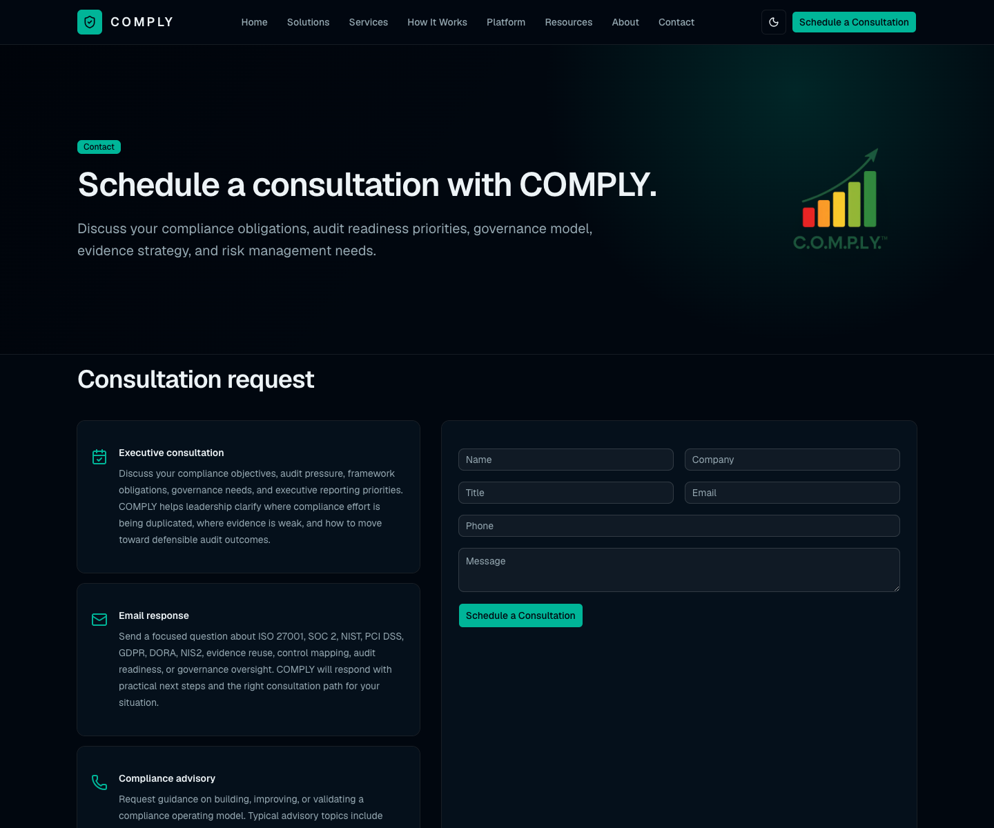
Contact page first-viewport screenshot captured from production.

Page purpose
Consultation request and lead capture page.

Detailed description
The Contact page invites visitors to schedule a consultation and provides three request paths: executive consultation, email response, and compliance advisory. It collects name, company, title, email, phone, and message so COMPLY can route the inquiry.

Major content areas
• Consultation request cards: Explain executive consultation, email response, and compliance advisory paths in detail.
• Form: Captures the visitor’s basic contact information and message for follow-up.

User experience and visual design
The page keeps the conversion path simple and direct. The left-side cards set expectations, while the right-side form keeps the action obvious.

Conversion and business role
This is the primary lead-capture page and the destination for the persistent Schedule a Consultation CTA.

Captured page headings
Schedule a consultation with COMPLY. — Discuss your compliance obligations, audit readiness priorities, governance model, evidence strategy, and risk management needs.
Consultation request — Discuss your compliance objectives, audit pressure, framework obligations, governance needs, and executive reporting priorities. COMPLY helps leadership clarify where compliance effort is being duplicated, where evidence is weak, and how to move toward defensible audit outcomes.

Appendix: Screenshot Capture Details
• Screenshots were captured from the production deployment at https://comply-website.vercel.app.
• Desktop viewport used for primary screenshots: 1440 x 1200 pixels.
• Both first-viewport and full-page screenshots were captured for each route in the temporary generation workspace.
• Pages captured: Home, Solutions, Services, How It Works, Platform, Resources, About, and Contact.
• The browser automation capture reported zero console or page errors for all pages.

